Project Design Phase-II
Data Flow Diagram & User Stories

Date | 02 November 2025
Team ID | NM2025TMID07661
Project Name | Streamlining Ticket Assignment for Efficient Support Operations
Maximum Marks | 4 Marks

Data Flow Diagrams:
A Data Flow Diagram (DFD) visually represents how support tickets move through the system and how assignment decisions are processed. It shows the interaction between the customer, support agent, team lead, and the ticket assignment automation system.
In this project, the DFD illustrates the complete ticket lifecycle:
- Ticket is raised by a customer
The system categorizes and analyzes the ticket
- The intelligent assignment engine selects an agent based on skills and workload
- The assigned agent updates status
- Team leads monitor workload and SLA performance
- Customers receive real-time updates
Example:
Flowchart Explanation:
- Ticket Creation by Customer
The process begins when a customer submits a support ticket. The ticket details enter the system for categorization and analysis.
- System-Driven Ticket Categorization & Assignment
The system categorizes the ticket based on priority and type, then the automatic assignment engine selects the most suitable support agent using skill and workload data.
- Workload Monitoring & Updates
Once assigned, workload data is updated in the database. A dashboard provides real-time ticket distribution and SLA monitoring for team leads.
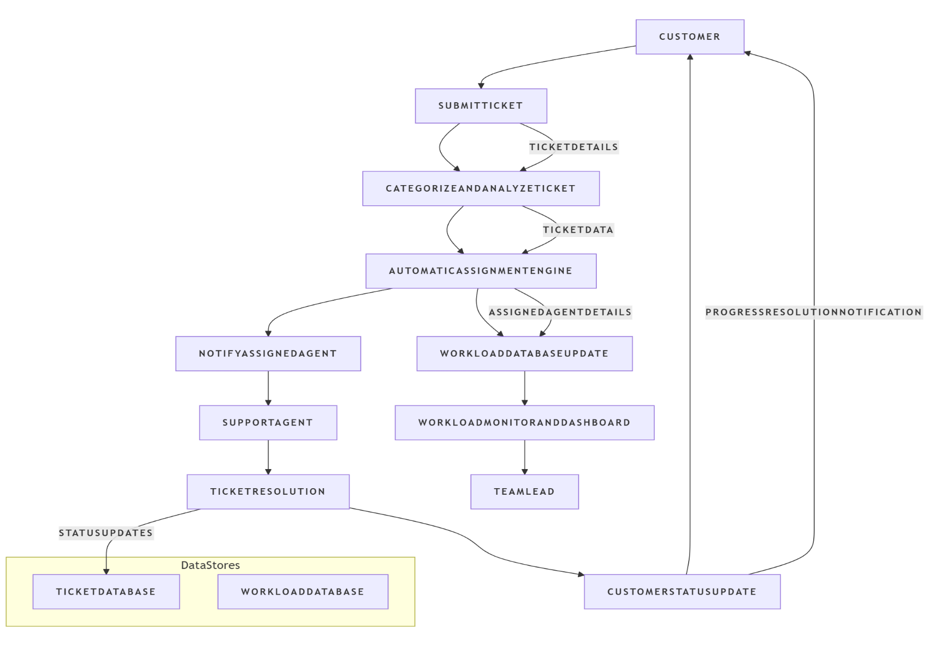

User Stories:
User stories define what different users need from the system in simple, goal-focused language. In this project, they help ensure the system blocks user deletion only when necessary, protecting incident data.

User Type | Functional  Requirement  (Epic) | User Story  Number | User Story / Task | Acceptance criteria | Priority | Release
Customer | Ticket Creation & Tracking | USN-1 | As a customer, I want to raise a support ticket easily so that my issues can be resolved quickly | Ticket is successfully created and visible with current status updates. | High | Sprint-1
System (Auto-Assignment) | Intelligent Ticket Assignment | USN-2 | As the system, I must assign tickets automatically to the most suitable agent based on skills and workload. | Ticket must be assigned immediately to an available and skilled agent. | High | Sprint-1
System (Notification) | Alerts & Escalation | USN-3 | As the system, I must notify the team lead when an SLA is at risk or ticket is delayed. | Escalation alerts must be triggered based on SLA breach rules. | High | Sprint-2
Support Agent | Ticket Handling | USN-4 | As an agent, I want to receive relevant tickets instantly so that I can solve issues efficiently. | Assigned tickets must display correctly in Agent Workspace. | High | Sprint-2

